LAB SHEET - 07

**Diyana Fernando - 30325**

Q1.

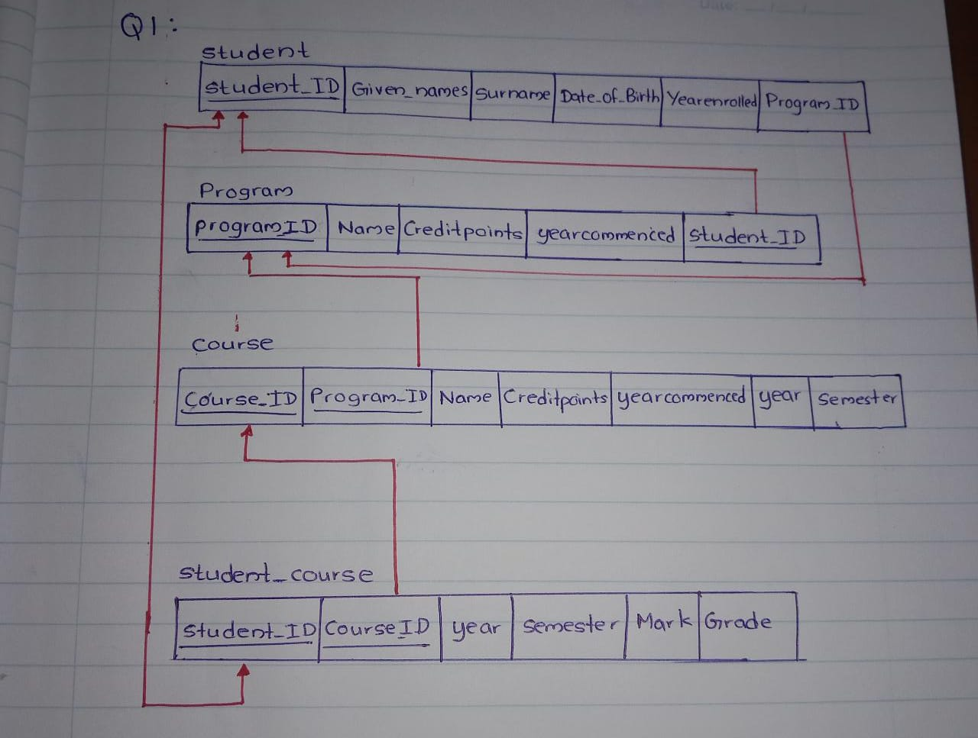

Q2

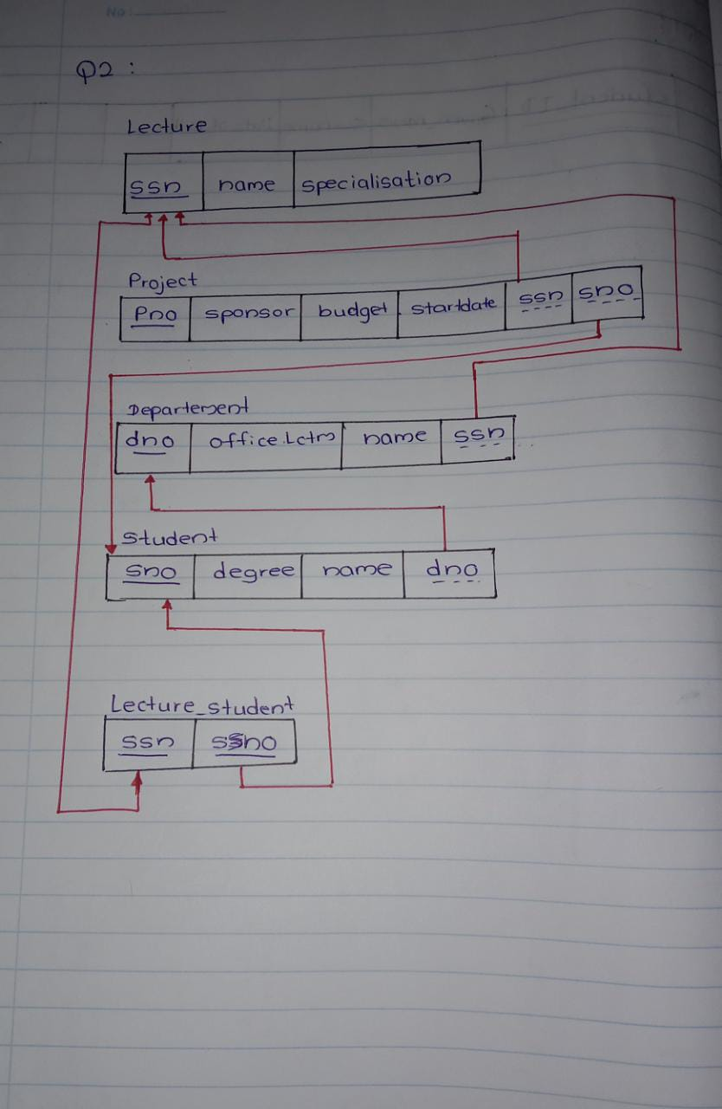

Q3

